Waveguide Switches up to 260 GHz
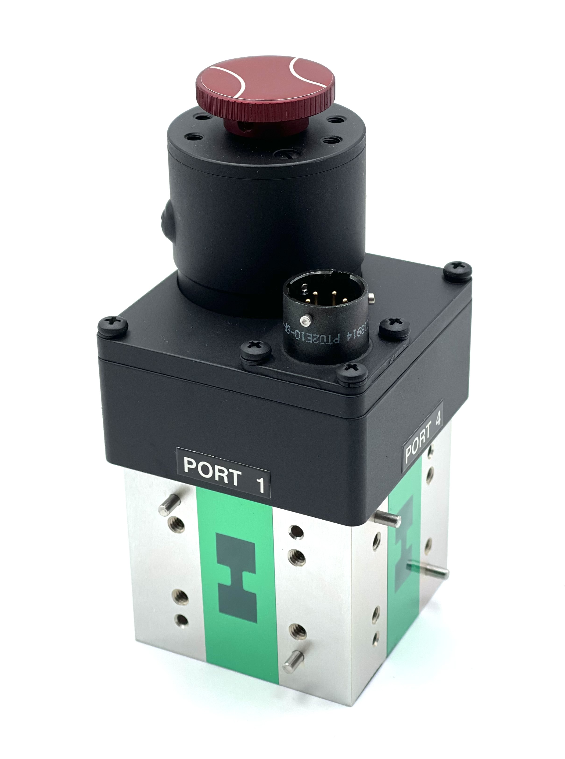

Waveguide Switches from WR975 to WR3

Waveguide MMIC based Switch up to 260 GHz (WR22-WR3)
Double Ridge Switches up to 18 GHz (WRD110 to WRD750)
Dual Waveguide Switches up to 33 GHz (WR34 to WR229)

Custom switches upon request

www.bq-microwave.de

